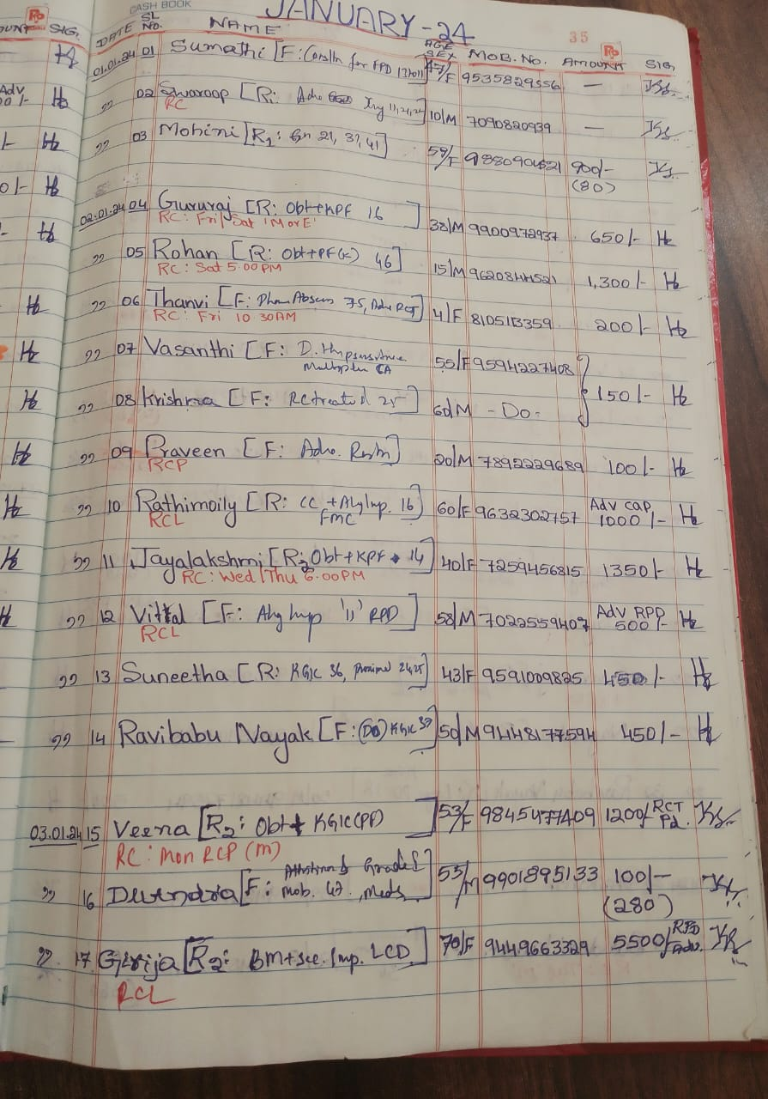
curl -i -b cookies.txt -X DELETE http://demo.testfire.net/bank/main.jsp

